EXP NO 5: CREATE A SIMPLE CLOUD SOFTWARE APPLICATION FOR LIBRARY BOOK RESERVATION SYSTEM FOR SIMATS LIBRARY USING ANY CLOUD SERVICE PROVIDER TO DEMONSTRATE SAAS
DATE:
AIM:
To Create a simple cloud software application for Library book reservation system for
SIMATS library using any Cloud Service Provider to demonstrate SaaS
PROCEDURE:
step1: Go to zoho.com.
step 2: Log into the zoho.com.
step 3: Select one application step.
step4: Enter application name as library book reservation system.
step 5: Created new application as library book reservation system.
step 6: Select one form
step 7: The software has been created.
IMPLEMENTATION:
step1: Go to zoho.com.
step 2: Log into the zoho.com.
step 3: Select one application step.
step4: Enter application name as library book reservation system.
step 5: Created new application as library book reservation system.
step 6: Select one form
step 7: The software has been created.
IMPLEMENTATION:
step1: Go to zoho.com.
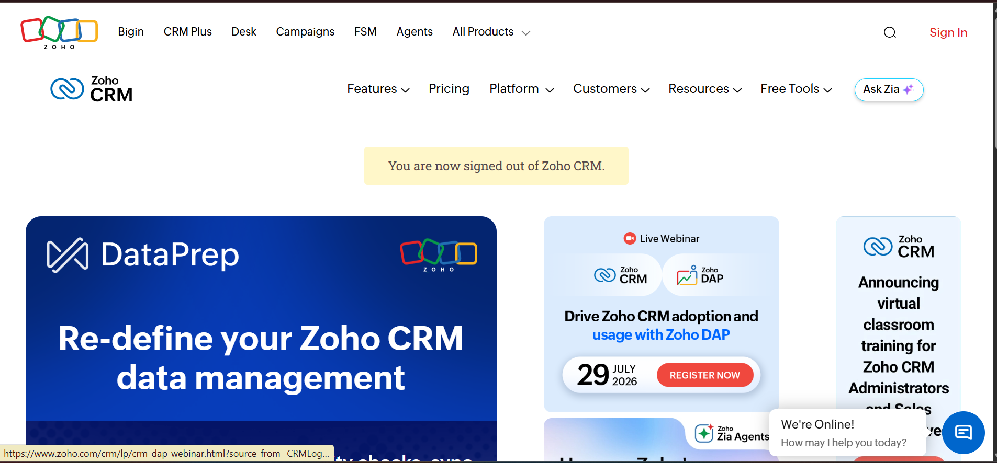
step 2: Log into the zoho.com.
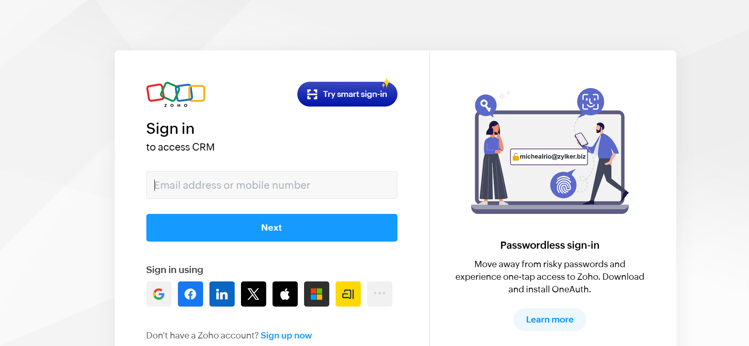
step 3: Select one application step.
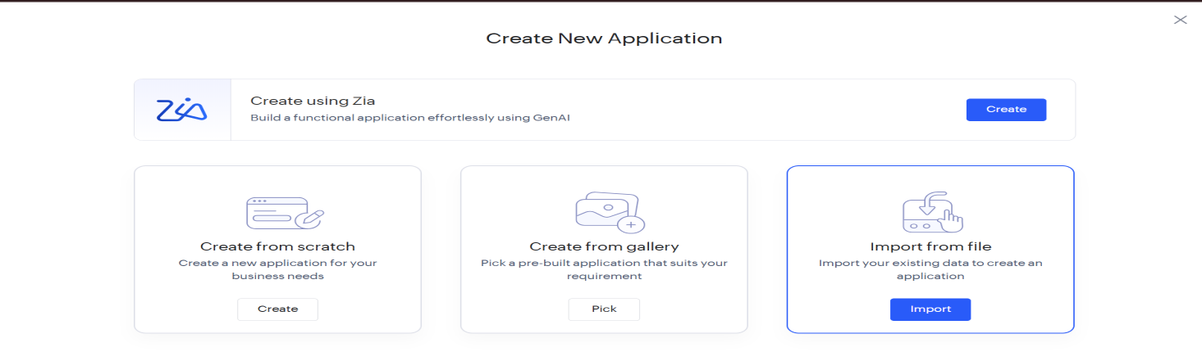
step4: Enter application name as library book reservation system.
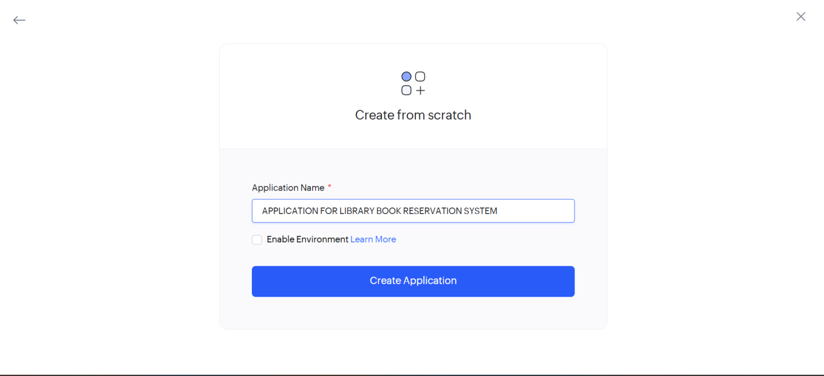
step 5: Created new application as library book reservation system.

step 6: Select one form
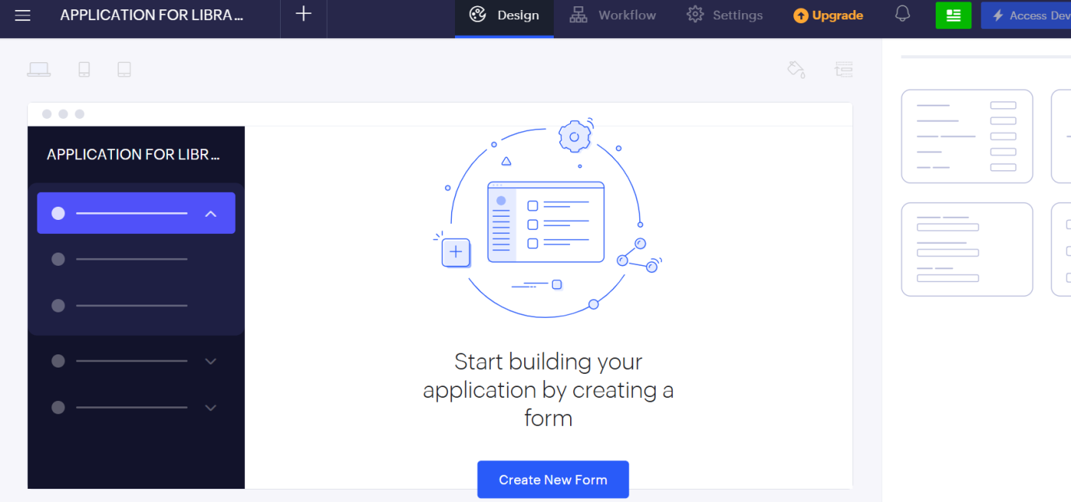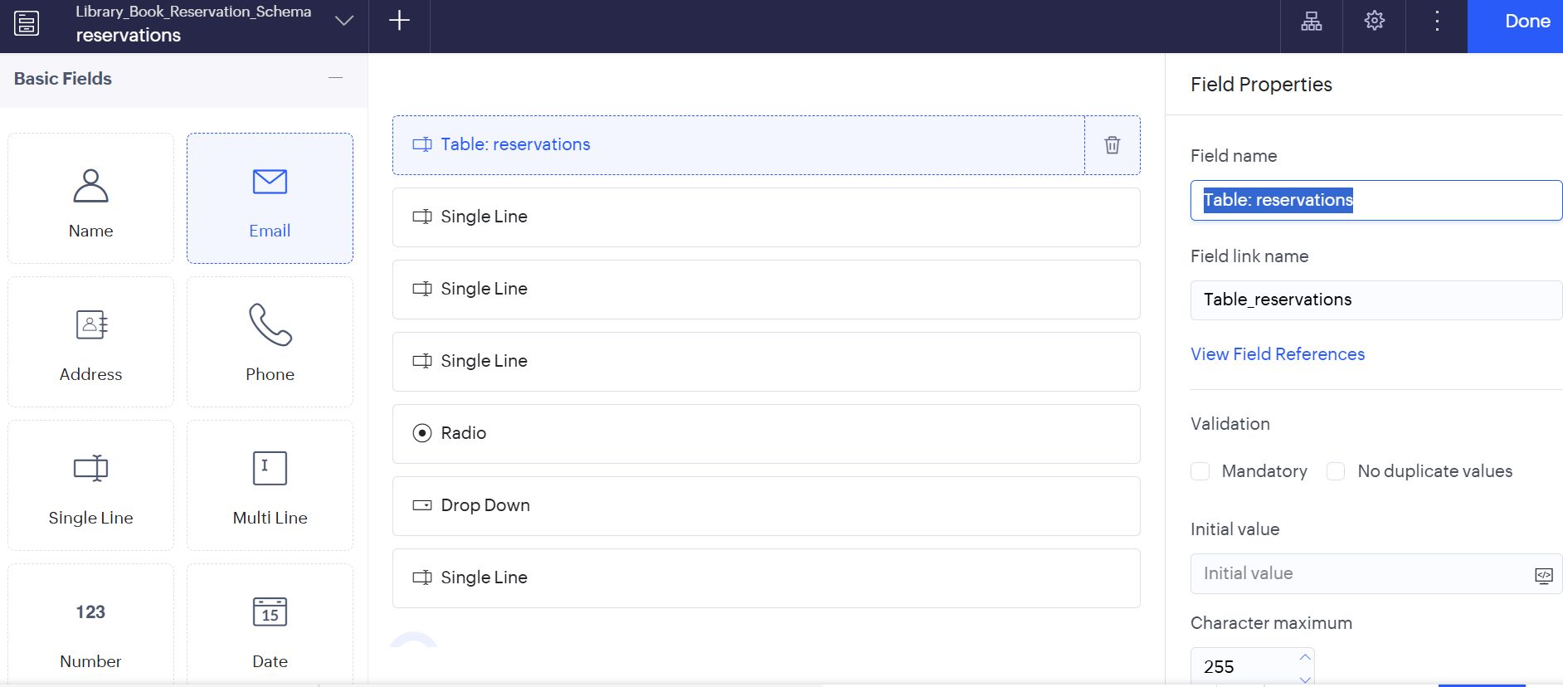
step 7: The software has been created.

